Domayne’s Intense Back Support Sofa

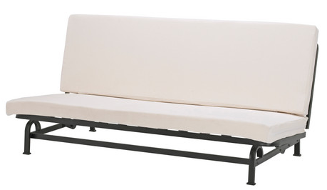

|  |
| --- |
| **DESCRIPTION** |
| Intense back support Sofa produced by Domayne’s Sofa, presents a sleek, High back design that is both Supporting and very comfortable. The extra-long back relaxes the spinal cord extra long legs on bottom provide stability for the sofa. Available in White, Brown bulky form and hand stitched leather cloth, the Delmard air filled leather with thick form will add comfort and class to the drawing room. |

|  |  |  |
| --- | --- | --- |
| **Price** | **650$** | |
| **Dimensions** | **H** x **W** x **L** | **35in x 32in x 66in** |
| **Features** | **After a back aching day you can relax and fix your back as quickly as you can say RELAXED** | |
| **Finished** | **Long Ledged Back** | |
| **Available in** | **Off-white and Brown** | |